Year 3 Timetable Example

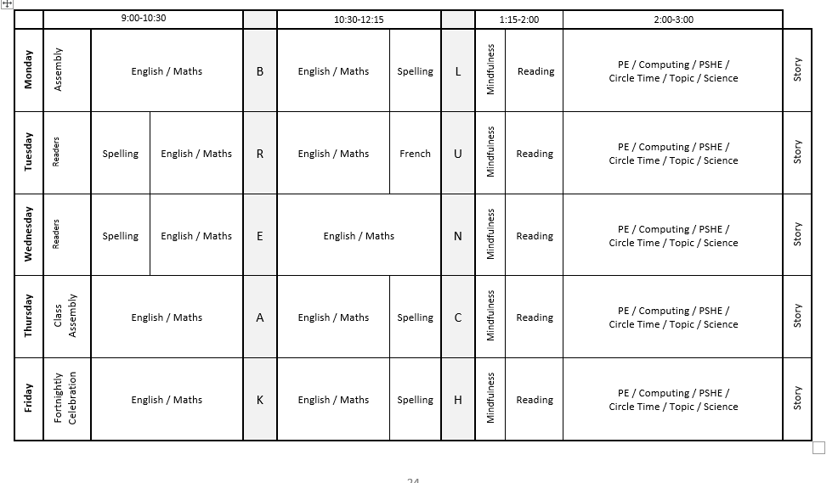
Year 4,5 and 6 Timetable Example


